**3iTABS - IT Services Company app – Design Phase**

The app enables to calculate the cost to acquire the services of an IT professional from 3iTABS. The company provides both software and hardware services, onsite and also from their remote offices (remote hardware repair services through tele-support).

1. The app opens with a splash screen with company name and an image and displayed for 3 seconds
2. A master/detail page is displayed with list of services offered along with full website view option
3. Depending on the service selected the details page will ask the user to input the number of hours
4. Upon clicking on the ‘calculate’ button the cost to acquire the services of a professional will be calculated and displayed in the last screen

The app is going to meet the minimum requirements by employing the following options,

1. Will use the shared preferences to calculate the cost (requirement 1)
2. Will display a toast message if the options were not selected using the radio button (requirement 4)
3. 2 items on the details page will be listed to choose from either software or hardware services (requirement 5)
4. Radio button, text view and web view will be used (requirement 6)
5. Generic relative layout is used in most screen designs with the exception of table layout for the master/detail item ‘software services’ to display two images for web design and product design (may or may not be used) (requirement 7)
6. The total cost is calculated based on the user input hours (requirement 8)
7. A splash screen is used (requirement 9)
8. Master/detail flow activity is employed (requirement 10)

I may tweak around a bit here and there and would try to meet 6 requirements of the above 8.

Please refer to the pictures below. I am planning to use the app in my portfolio. Let me know if you have any suggestions.

Thanks,

Arun.

1. Spalsh screen



1. Master/Detail flow activity (Master screen)

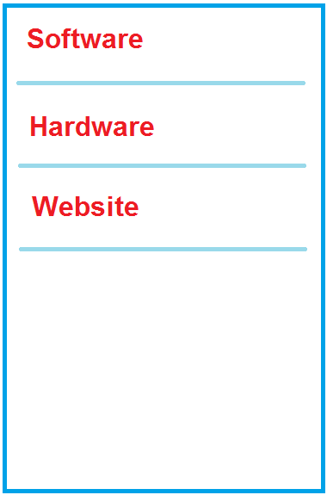

1. Master/Detail flow activity, details pages with radio buttons, calculate button

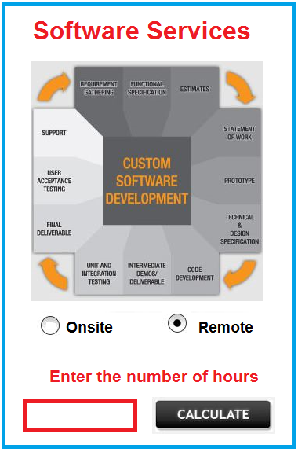 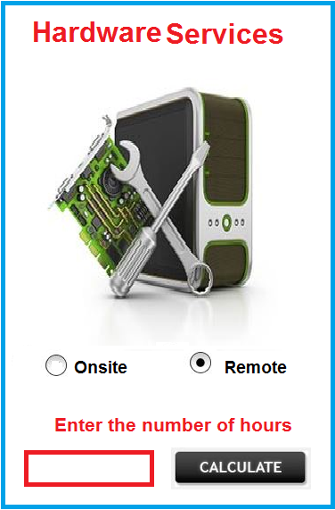

1. Calculated result displayed in text view, using shared preferences method based on the user input hours

